Hi Sunny –

Everything is looking really, really great! Thank you for implementing the changes!

I have a few more changes to request, but we will be finished after these…

1 – Default rows of tables

Can the default amount of rows shown in the zinggrid table be changed to 25 (from the current 10)?

2 – Can we add additional lines to the line chart?

(and a legend to the right of it too?

I have included a new CSV that contains daily download counts for each region (ie., Europe, Oceania, Americas, Asia, Africa). There is also another region named “ALL” which contains aggregate download counts for everything.

Can these each be added to the line chart? There will only be a need for one “ALL” line. So can the current data series being graphed be replaced with the one in this CSV named ALL? (this way, we wont have two duplicate lines).

Separately, can the ALL data series be the only one that’s graphed by default? Therefore, all others would only be activated when the user clicks on the label in the legend.

3 – Dot size sensitivity

The slider for dot size sensitivity works great. Is it possible to change the default setting? If so, can it be set to max by default? See below:

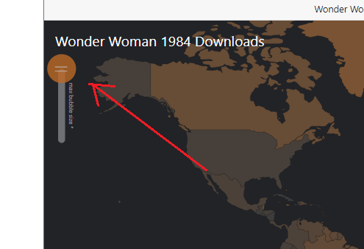

4 – Start date for Wonder Woman 1984 chart

Can the start date on the Wonder Woman 1984 chart be changed to December 1st? (right now, it begins in November)

5 – Additional columns for table

I have exported two new CSVs that will be used for the zinggrid tables. Can these be implmemetned please? The big change is that three additional columns will be added. The final columns will be:

* Torrent Hash
* Torrent Title
* First Seen Date
* Last Seen Date
* Download Count
* First IP Address
* Full Movie